Choose your Theme: ☐ N°1 ☐ N°2 ☐ N°3
Choose your Contribution: ☐ Oral ☐ Poster
CrysTech AI’26 abstract template – put here the title of your presentation
Mohammed Author¹, Riad SecondAuthor^{2,3}
¹First affiliation
Mohammed.author@correspondence.email.com
²Second affiliation
³Third affiliation

This is an abstract template for the CrysTech-AI’26 Conference, which be held 26-27.01.2026 in El Oued University. Please keep your abstract to one page including figures, tables, references, acknowledgements, etc. The abstract should include the following sections: (1) Objectives, (2) Methods, (3) Results.The abstract should be written in English and may include figures and other objects as long as they fit within the one-page limit. Do not vary the margins or change the settings of this template (line spacing, font size, etc.).
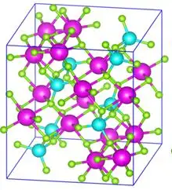
Figure 1. Example of figure and figure caption embedded in the main abstract text. Do not forget to cite the figure in the text of your abstract.
The figure caption should be placed below the figure (Fig. 1). It is recommended to position figures and captions using tables with transparent borders as suggested in this template.
Acknowledgements of funding may be placed after the main text of the abstract. References should be numbered consecutively [1]. A suggested style for references is given at the end of the template [2].
The abstract should be submitted as an MS Word file “AuthorName.docx” and PDF file “AuthorName.pdf”.
You will receive an acknowledgement of the successful receipt of your abstract. If you do not receive such a confirmation, please contact the organizers.
The deadline for abstract submission is 25 November , 2025. Notification of acceptance is expected by 20 December, 2025.

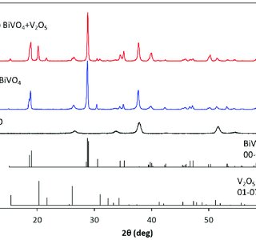
Figure 2. Example of figure and figure capture following the main abstract text. Do not forget to cite figure in the text of your abstract.

Keywords: Keyword1; Keyword2; Keyword3; Keyword4; (Maximum 4).

References
[1] A.S. Clark et al., Materials Research Letters 12, 32 (2017)
[2] B. Liu et al., PRB 12, 247678 (2021)
[3] I.T. Prius et al., Sci. Rep. 3, 222 (2020)

